
Name: ______________________ Class: ______ Time: 45 minutes Total Mark:____/42
Year 8

Mid Term 1 Test

2021

Show working and answers on this sheet. Show working in sufficient detail to support your answers. Incorrect answers without supporting reasoning will be allocated zero marks.

Resources: 1 x A4 page of notes (1 sided)
Non Calculator
20 minutes

Question 1 4 marks
Solve the following questions

- $35-2×10$ | - $(10÷5+3)×4$
- $3×(15-9)$ | - $4^{2}-5×3$

Question 2 4 marks
Calculate the following;

- $-4+8=$ | - $-7×-3=$
- $32÷\left(-8\right)=$ | - $-12-\left(-11\right)=$

Question 3 6 marks
Simplify the following

- $3a+9a$ | - $2x+5x-4y$
- $4x-x+5y-2y$ | - $12ab+5a-3ba+5a$

Question 4 4 Marks
Calculate the following

- $4×3a$ | - $15x÷3$
- $9a×2b$ | - $\frac{24xy}{12x}$

Question 5 4 marks
If a=5, b=7 and c=-2, calculate the following.

- $4×3a$ | - $a+2c$
- $ac+ab$ | - $3b+c$
Calculator Allowed
25 minutes
Question 6 4 marks

Convert the following units

- 1.6km=___________________m | - 1200cm= _______________m
- 400$mm^{2}= _____________________cm^{2}$ | - 3.2km= __________________ cm
Question 7 4 marks
Calculate the perimeter of the following shapes.
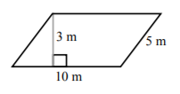 | 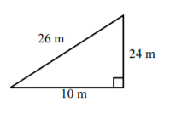
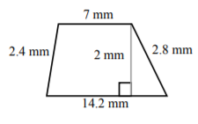 | 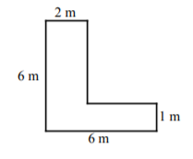

Question 8 4 marks
Calculate the area of the following
 | 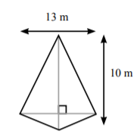
 | 

Question 9 3 marks
The area of a parallelogram is the same as the area of a square with the side length of 60cm. Calculate the height of the parallelogram if the base is 50cm long.

Question 10 2,3: 5 marks

Farmer Jess is building a rectangular paddock that is 20m by 50m. She needs to put a fence around the paddock and grow grass in the paddock.

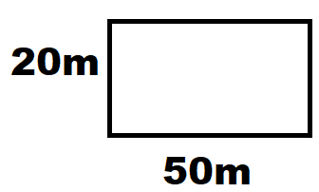
- How much fencing will Jess require in meters?

- If a box of grass seeds covers $30m^{2}$, how many boxes of grass seed does she require to grow grass in her paddock?

Question 11 2 marks
Insert a x sign or $÷$ sign to make these equations true

- -2 ___ 3 ___ (-6) = 1 b) -32 ___ (-3) ___ (-2) = -48

